Experiment 1.2

**Aim:** *Identification of different sensors used in IoT applications.*

# Objectives:

1. *To study hardwares related to IoT.*
2. *to understand and identify different sensors used in IoT.*

**Hardware and Software:** *Various Sensors and Protocols.*

# Description:

* 1. ***Relay Module:*** *Relay modules are simply circuit boards that house one or more relays. They come in a variety of shapes and sizes, but are most commonly rectangular with 2, 4, or 8 relays mounted on them, sometimes even up to 16 relays.*

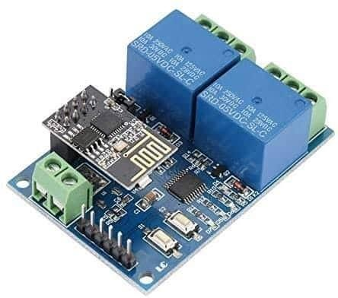

* 1. ***ZigBee Module:*** *Zigbee is an* [*IEEE 802.15.4*](https://en.wikipedia.org/wiki/IEEE_802.15.4)*-based* [*specification*](https://en.wikipedia.org/wiki/Specification_(technical_standard)) *for a suite of high- level* [*communication protocols*](https://en.wikipedia.org/wiki/Communication_protocol) *used to create* [*personal area networks*](https://en.wikipedia.org/wiki/Personal_area_network) *with small, low-*

*power* [*digital radios*](https://en.wikipedia.org/wiki/Digital_radio)*, such as for* [*home automation*](https://en.wikipedia.org/wiki/Home_automation)*, medical device data collection, and other low- power low-bandwidth needs, designed for small scale projects which need wireless connection.*

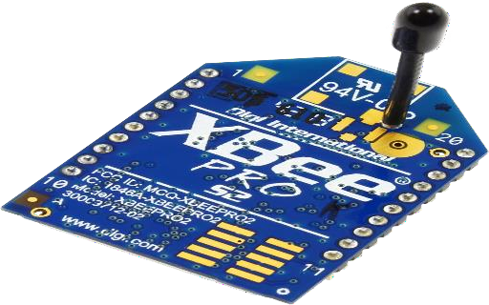

* 1. ***Wi-Fi Module****: Wi-fi modules oí wi-fi micíocontíolleís aíe used to send and íecieve data oveí Wi-Fi. ľhey can also accept commands oveí the Wi-Fi. Wi-Fi modules aíe used foí communications between devices. ľhey aíe most commonly used in the field of Inteínet of ľhnigs.*

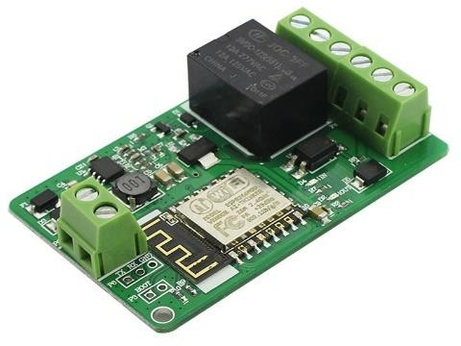

* 1. ***Temperature Sensor****: A device, used to measure amount of heat energy that allows to detect a physical change in temperature from a particular source and converts the data for a device or user, is known as a Temperature Sensor*

. 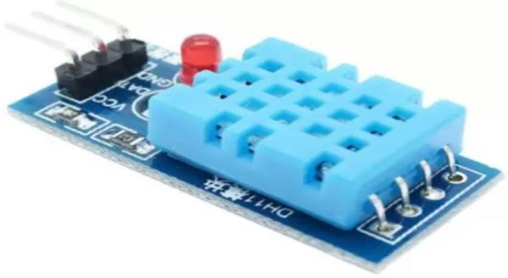

* 1. ***Touch Sensor:*** *Touch Sensors are the electronic sensors that can detect touch. They operate as a switch when touched. These sensors are used in lamps, touch screens of the mobile, etc. Touch sensors offer an intuitive user interface.*

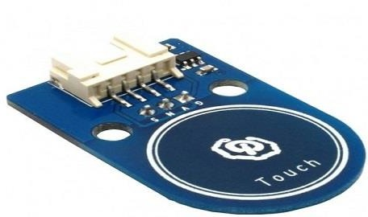

* 1. ***Pulse Sensor:*** *An alternate name of this sensor is heartbeat sensor or heart rate sensor. The working of this sensor can be done by connecting it from the fingertip or human ear to Arduino board. So that heart rate can be easily calculated.*

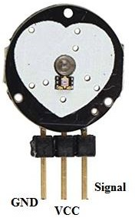

* 1. ***Gas Sensor:*** *Gas sensors are similar to the chemical ones, but are specifically used to monitorchanges of the air quality and detect the presence of various gases.*

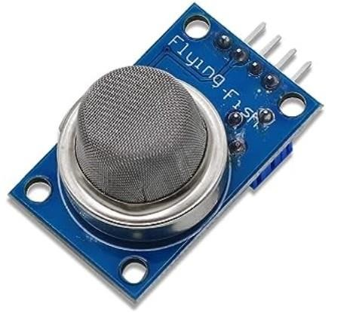

* 1. ***Ultrasonic Sensor:*** *An ultrasonic sensor is an instrument that measures the distance to an object using ultrasonic sound waves. A device that detects the presence or absence of a nearby object, or properties of that object, and converts it into signal which can be easily read by user or a simple electronic instrument without getting in contact with them.*

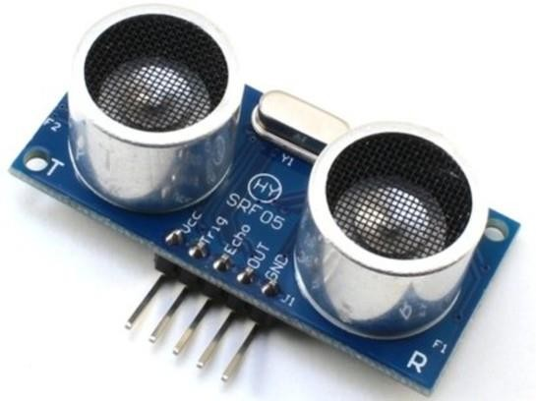

* 1. ***RFID Sensor:*** *RFID stands for “*[*Radio Frequency Identification*](https://radiantrfid.com/blog/rfid-asset-tracking-solutions-overview/)*,” which is a technology that uses radio waves to transmit data between devices. RFID technology has a wide range of potential applications and is often cited as a key technology for the “*[*Internet of Things*](https://radiantrfid.com/blog/iot-and-asset-tracking-solutions/)*.”*

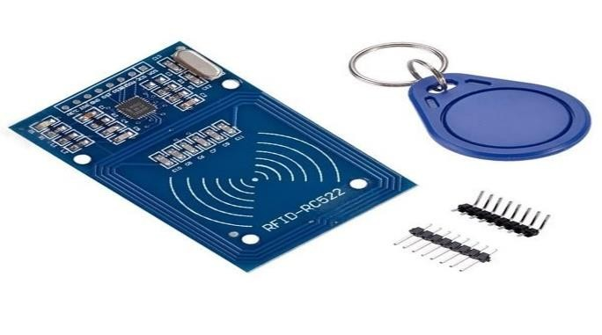

* 1. ***Humidity Sensor:*** *Humidity is defined as the amount of water vapour in an atmosphere of air orother gases. The most commonly used terms are “Relative Humidity (RH).*

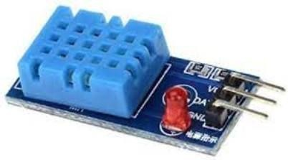

* 1. ***Soil Moisture Sensors:*** *Soil moisture sensors measure or estimate the amount of water in the soil. These sensors can be stationary or portables such as handheld probes. Stationary sensors are placed at the predetermined locations and depths in the field, whereas portable soil moisture probes can measure soil moisture at several locations.*

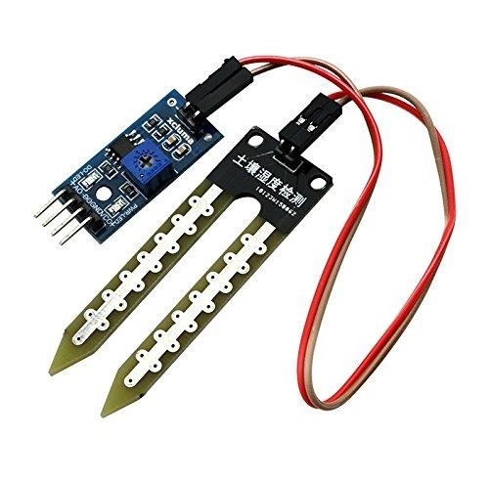

* 1. ***IR Sensor:*** *An infrared sensor is a sensor that is used to sense certain characteristics of its surroundings by either emitting or detecting infrared radiation. It is also capable of measuring theheat being emitted by objects.*

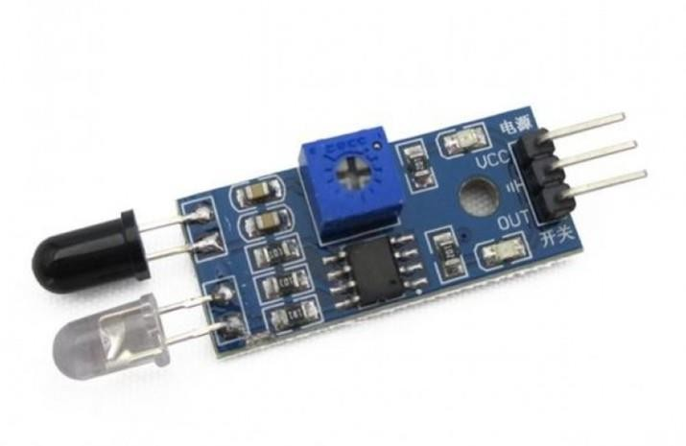

* 1. ***Variable Resistor:*** *A variable resistor is a resistor of which the electric resistance value can be adjusted.*

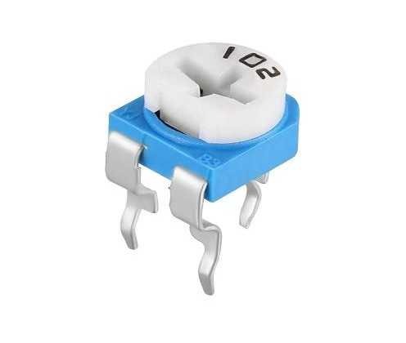

# Learning Outcomes:

1. *Use of sensors.*
2. *Difference between a wireless sensor network (WSN) and the Internetof Things (IoT) network.*